**JS Advanced: Exam – 23.02.20**

Exam problems for the ["JavaScript Advanced" course @ SoftUni](https://softuni.bg/courses/js-advanced).

# Problem 1. Blog (DOM Manipulation)

### Use the Given Skeleton to Solve This Problem.

**Note: You Have NO Permission to Change Directly the Given HTML (Index.html File).**

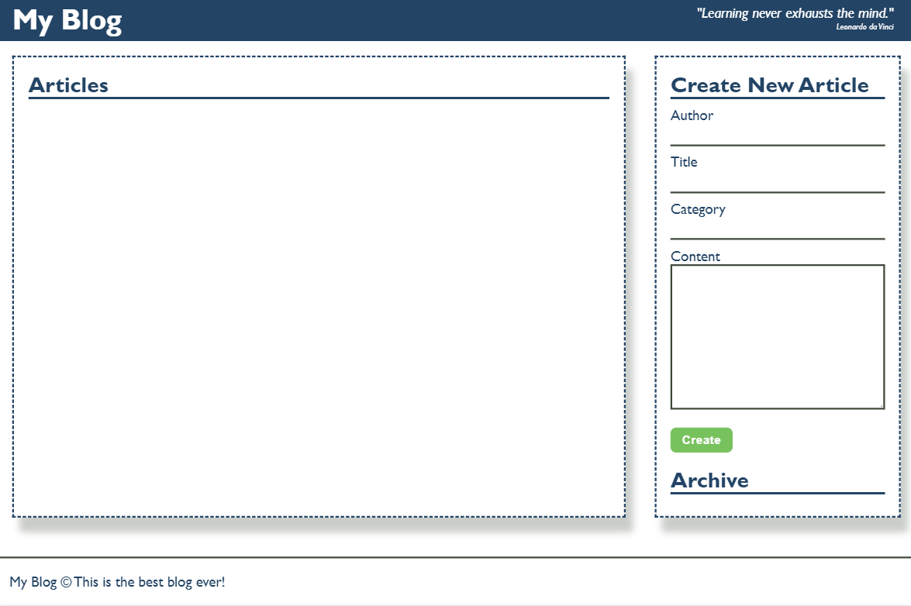

### Your Task

Write the missing JavaScript code to make the Blog application work as expected.

You should be able to **create** new articles.

Each article has **name, title, category** and **content**. When you click the **[Create]** button, a new **article item** should be added to the articles **section**.

The new item should have the **following structure**:

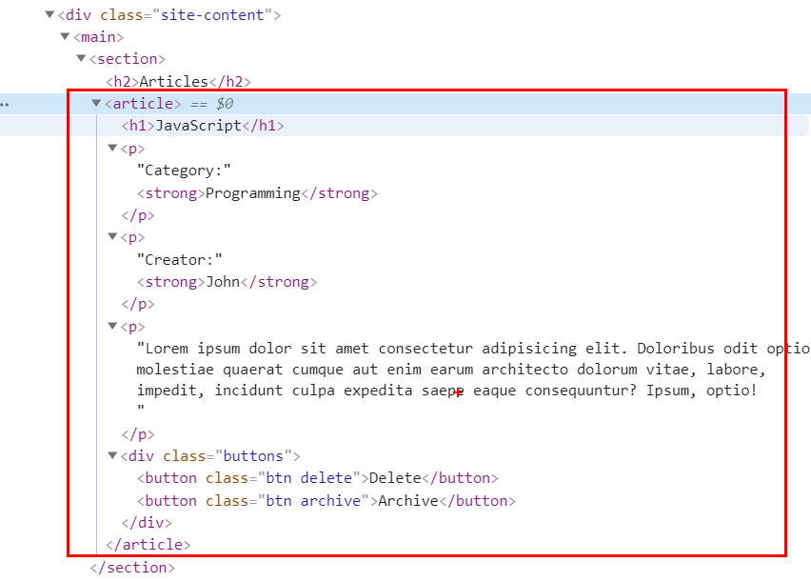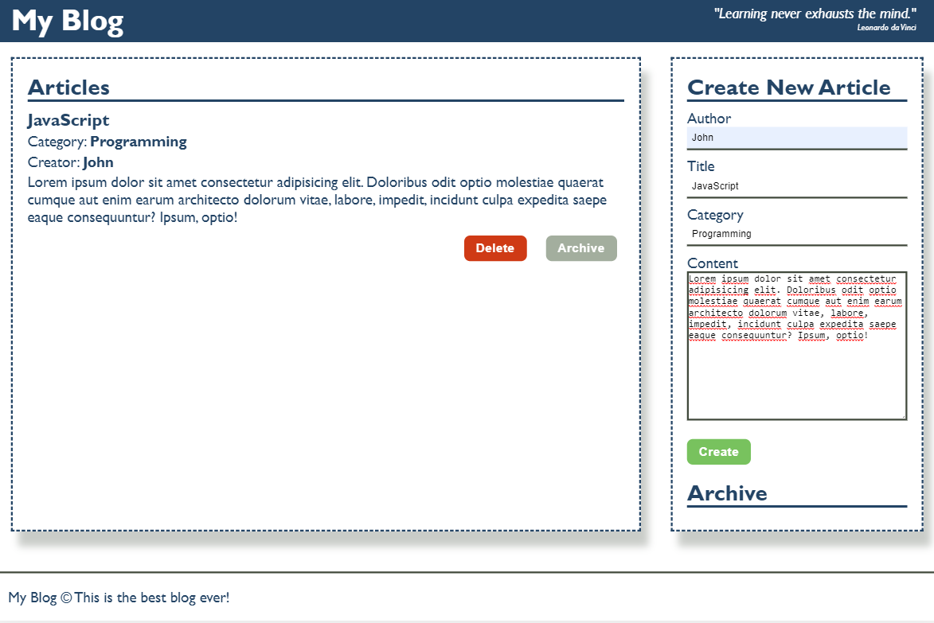

The new item should have the **following structure**:

* Append two buttons, which are in a **div** element with class **"buttons"** to each article item
  + **[Delete]** button should have the following classes: **"btn" and "delete"**
  + **[Archive]** button should have the following classes: **"btn" and "archive"**

When you click the **[Archive]** button you should move the article to the **ul** in the archive section. Archive section should be **sorted by title**.

**Important!** Do not move the entire article, but only the title of the article.

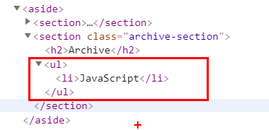

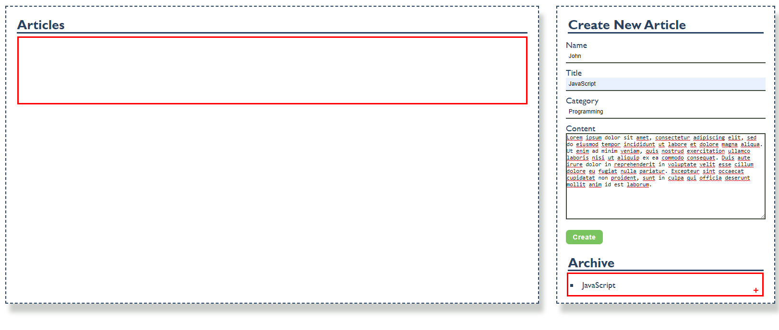

When you click the **[Delete]** button you should delete the entire article.

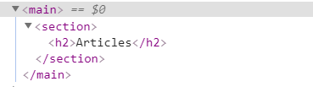

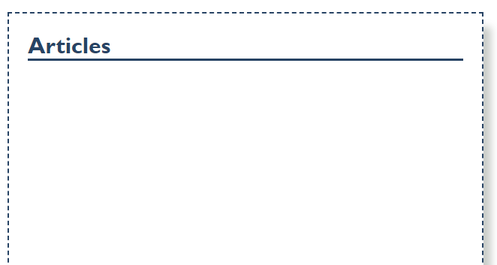

*GOOD LUCK!*